**WEB APPLICATION DEVELOPMENT LAB**

**12-12-2024**

**TASK 3**

Sai Ganesh Eswaraprasad

HU22CSEN0100287

HOME PAGE

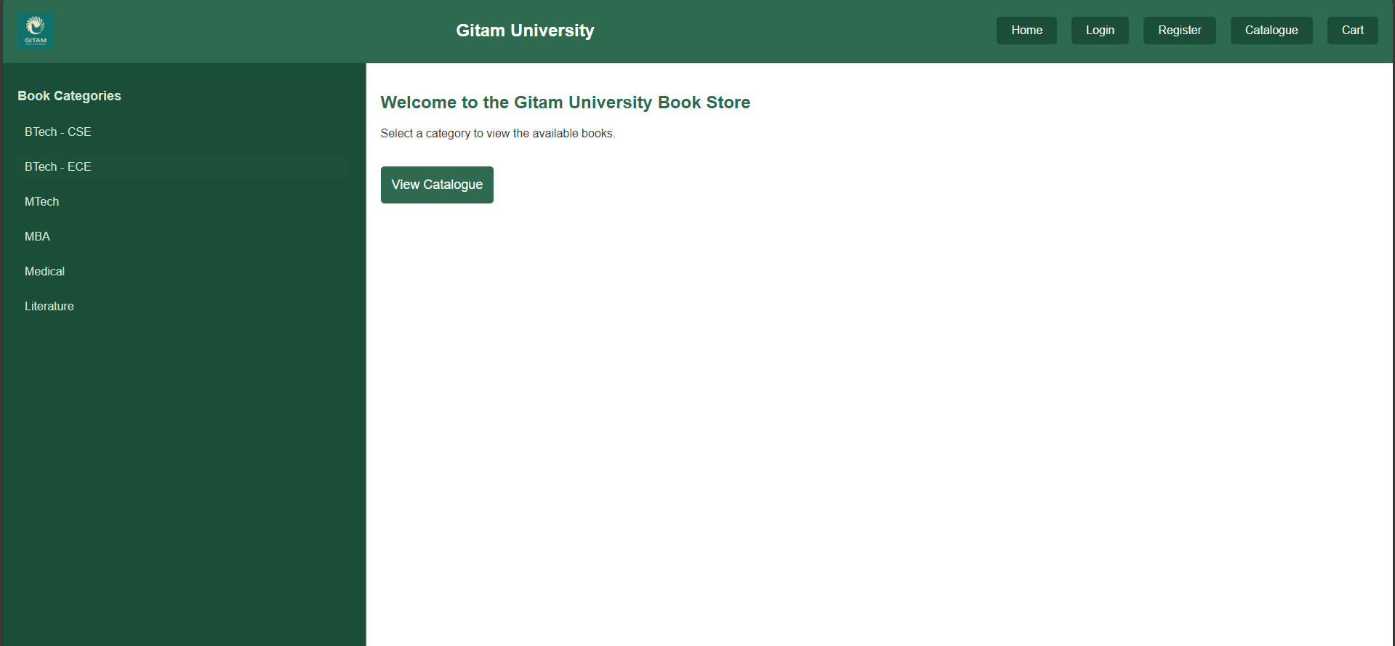

LOGIN

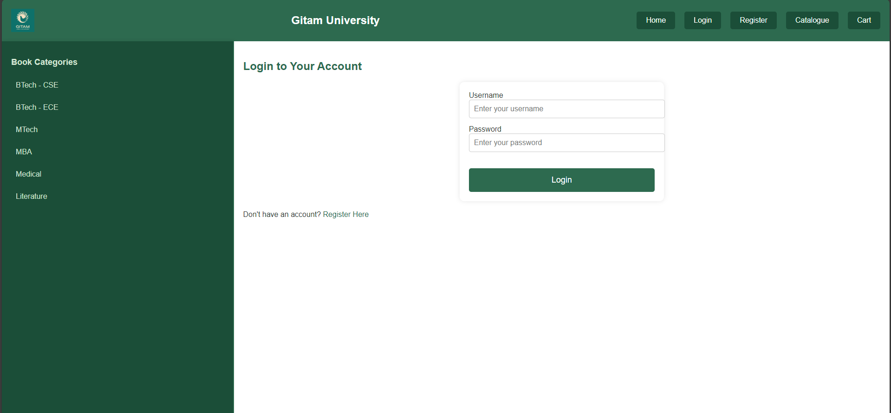

REGISTER

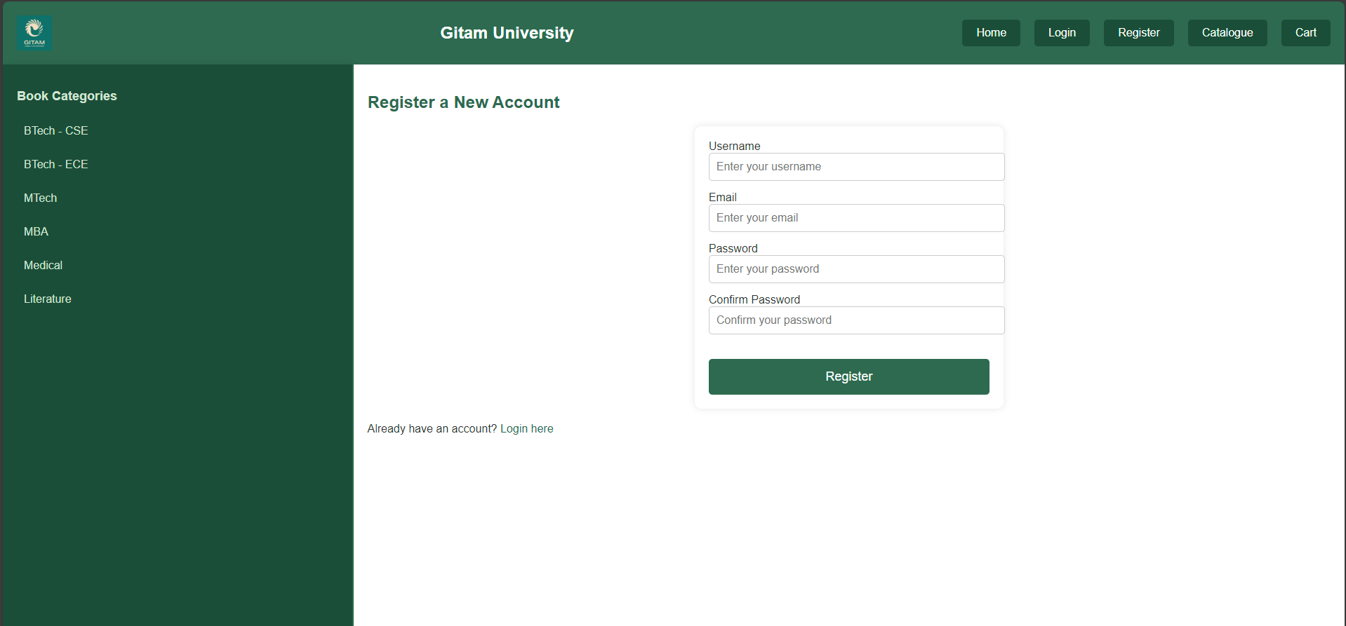

CATALOGUE

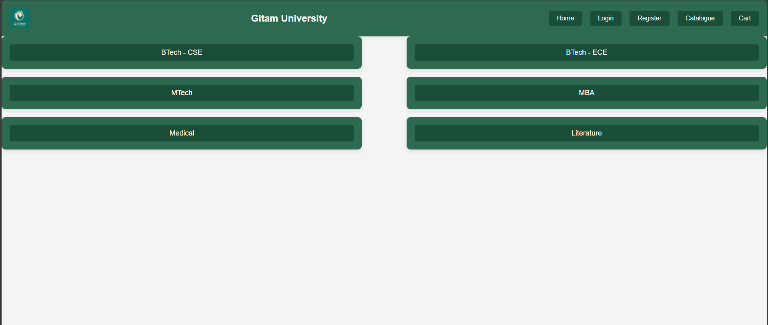

CART

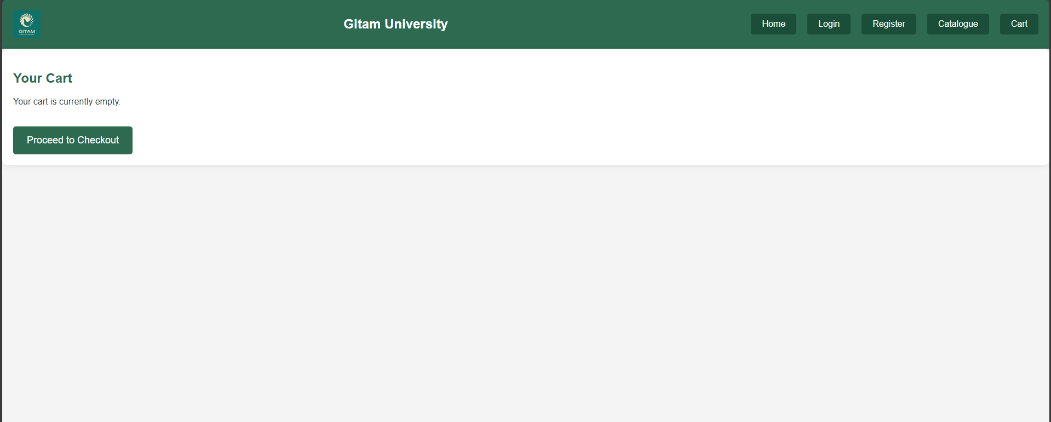

CATALOGUE LINKS DIRECTS TO

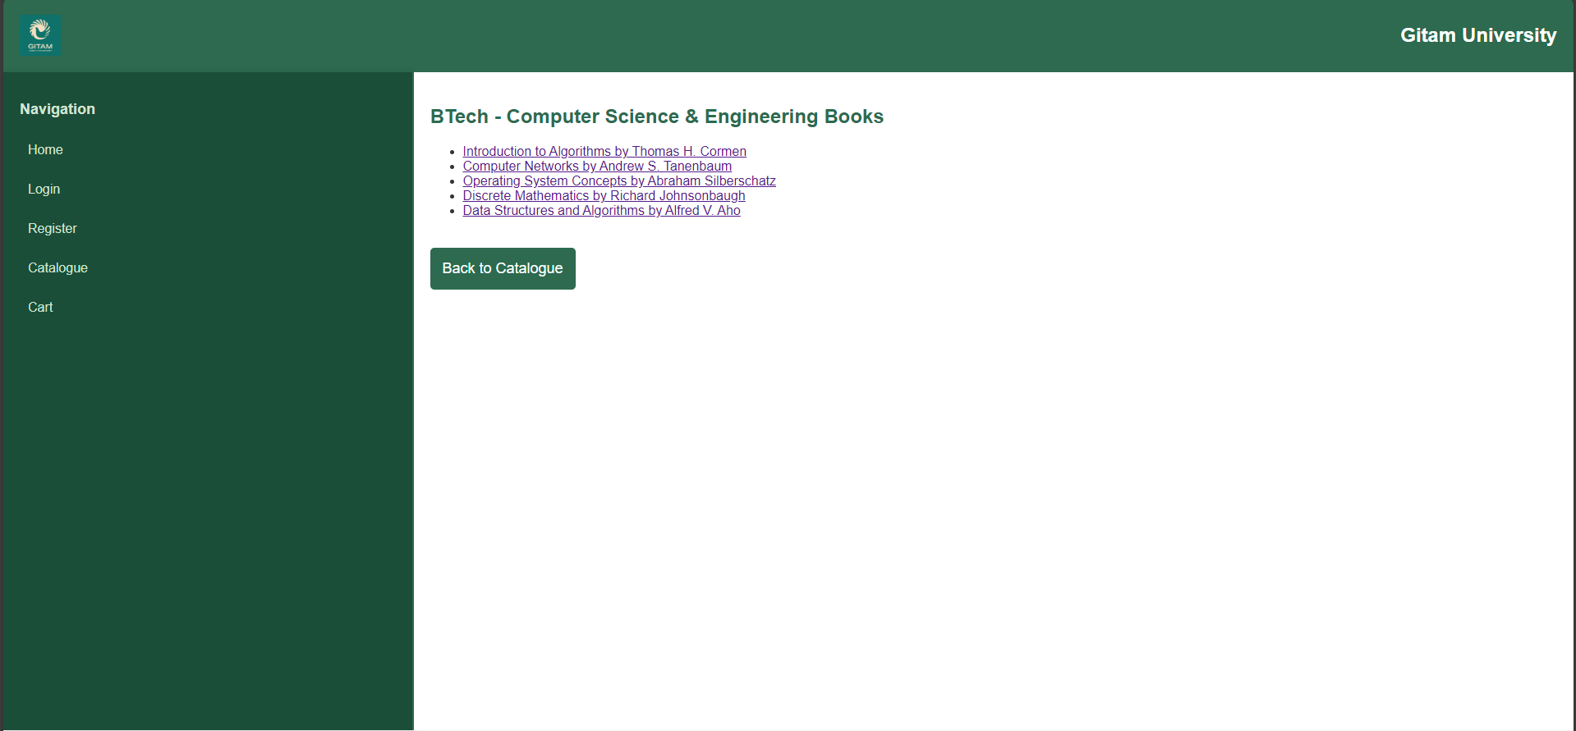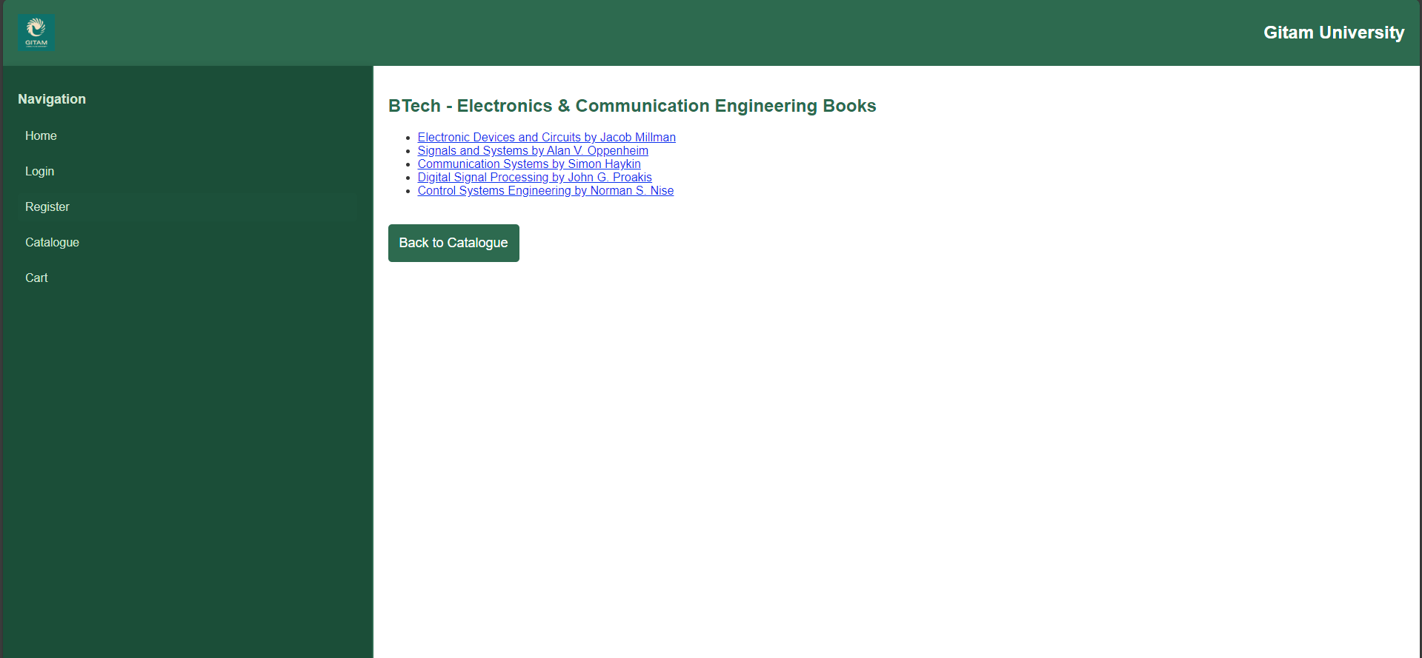

CODES

Index.html

<!DOCTYPE html>

<html lang="en">

<head>

    <meta charset="UTF-8">

    <meta name="viewport" content="width=device-width, initial-scale=1.0">

    <title>Online Book Store - Gitam University</title>

    <link rel="stylesheet" href="styles.css">

</head>

<body>

    <!-- Top Frame with Gitam University Logo and Name -->

    <div id="top-frame">

        <img src="logo.png" alt="Gitam University Logo" id="university-logo">

        <h1>Gitam University</h1>

        <div id="nav-links">

            <a href="index.html">Home</a>

            <a href="login.html">Login</a>

            <a href="register.html">Register</a>

            <a href="catalogue.html">Catalogue</a>

            <a href="cart.html">Cart</a>

        </div>

    </div>

    <!-- Main Content Container -->

    <div class="main-container">

        <div id="left-frame">

            <h2>Book Categories</h2>

            <ul>

                <li><a href="btech_cse.html" target="right-frame">BTech - CSE</a></li>

                <li><a href="btech_ece.html" target="right-frame">BTech - ECE</a></li>

                <li><a href="mtech.html" target="right-frame">MTech</a></li>

                <li><a href="mba.html" target="right-frame">MBA</a></li>

                <li><a href="medical.html" target="right-frame">Medical</a></li>

                <li><a href="literature.html" target="right-frame">Literature</a></li>

            </ul>

        </div>

        <div id="right-frame">

            <h2>Welcome to the Gitam University Book Store</h2>

            <p>Select a category to view the available books. </p>

            <button onclick="location.href='catalogue.html'">View Catalogue</button>

        </div>

    </div>

</body>

</html>

Login.html

<!DOCTYPE html>

<html lang="en">

<head>

    <meta charset="UTF-8">

    <meta name="viewport" content="width=device-width, initial-scale=1.0">

    <title>Login - Online Book Store - Gitam University</title>

    <link rel="stylesheet" href="styles.css">

</head>

<body>

    <!-- Top Frame with Gitam University Logo and Name -->

    <div id="top-frame">

        <img src="logo.png" alt="Gitam University Logo" id="university-logo">

        <h1>Gitam University</h1>

        <div id="nav-links">

            <a href="index.html">Home</a>

            <a href="login.html">Login</a>

            <a href="register.html">Register</a>

            <a href="catalogue.html">Catalogue</a>

            <a href="cart.html">Cart</a>

        </div>

    </div>

    <!-- Login Form -->

    <div class="main-container">

        <div id="left-frame">

            <h2>Book Categories</h2>

            <ul>

                <li><a href="btech_cse.html" target="right-frame">BTech - CSE</a></li>

                <li><a href="btech_ece.html" target="right-frame">BTech - ECE</a></li>

                <li><a href="mtech.html" target="right-frame">MTech</a></li>

                <li><a href="mba.html" target="right-frame">MBA</a></li>

                <li><a href="medical.html" target="right-frame">Medical</a></li>

                <li><a href="literature.html" target="right-frame">Literature</a></li>

            </ul>

        </div>

        <div id="right-frame">

            <h2>Login to Your Account</h2>

            <form action="login_process.html" method="POST">

                <div class="form-group">

                    <label for="username">Username</label>

                    <input type="text" id="username" name="username" placeholder="Enter your username" required>

                </div>

                <div class="form-group">

                    <label for="password">Password</label>

                    <input type="password" id="password" name="password" placeholder="Enter your password" required>

                </div>

                <button type="submit">Login</button>

            </form>

            <p>Don't have an account? <a href="register.html">Register Here</a></p>

        </div>

    </div>

</body>

</html>

Register.html

<!DOCTYPE html>

<html lang="en">

<head>

    <meta charset="UTF-8">

    <meta name="viewport" content="width=device-width, initial-scale=1.0">

    <title>Register - Online Book Store - Gitam University</title>

    <link rel="stylesheet" href="styles.css">

</head>

<body>

    <!-- Top Frame with Gitam University Logo and Name -->

    <div id="top-frame">

        <img src="logo.png" alt="Gitam University Logo" id="university-logo">

        <h1>Gitam University</h1>

        <div id="nav-links">

            <a href="index.html">Home</a>

            <a href="login.html">Login</a>

            <a href="register.html">Register</a>

            <a href="catalogue.html">Catalogue</a>

            <a href="cart.html">Cart</a>

        </div>

    </div>

    <!-- Registration Form -->

    <div class="main-container">

        <div id="left-frame">

            <h2>Book Categories</h2>

            <ul>

                <li><a href="btech_cse.html" target="right-frame">BTech - CSE</a></li>

                <li><a href="btech_ece.html" target="right-frame">BTech - ECE</a></li>

                <li><a href="mtech.html" target="right-frame">MTech</a></li>

                <li><a href="mba.html" target="right-frame">MBA</a></li>

                <li><a href="medical.html" target="right-frame">Medical</a></li>

                <li><a href="literature.html" target="right-frame">Literature</a></li>

            </ul>

        </div>

        <div id="right-frame">

            <h2>Register a New Account</h2>

            <form action="register_process.html" method="POST">

                <div class="form-group">

                    <label for="username">Username</label>

                    <input type="text" id="username" name="username" placeholder="Enter your username" required>

                </div>

                <div class="form-group">

                    <label for="email">Email</label>

                    <input type="email" id="email" name="email" placeholder="Enter your email" required>

                </div>

                <div class="form-group">

                    <label for="password">Password</label>

                    <input type="password" id="password" name="password" placeholder="Enter your password" required>

                </div>

                <div class="form-group">

                    <label for="confirm_password">Confirm Password</label>

                    <input type="password" id="confirm_password" name="confirm_password" placeholder="Confirm your password" required>

                </div>

                <button type="submit">Register</button>

            </form>

            <p>Already have an account? <a href="login.html">Login here</a></p>

        </div>

    </div>

</body>

</html>

Catalogue.html

<!DOCTYPE html>

<html lang="en">

<head>

    <meta charset="UTF-8">

    <meta name="viewport" content="width=device-width, initial-scale=1.0">

    <title>Catalogue - Online Book Store</title>

    <link rel="stylesheet" href="styles.css">

</head>

<body>

    <!-- Top Frame: Logo, College Name, and Navigation Links -->

    <div id="top-frame">

        <img src="logo.png" alt="Gitam University Logo" id="university-logo">

        <h1>Gitam University</h1>

        <div id="nav-links">

            <a href="index.html">Home</a>

            <a href="login.html">Login</a>

            <a href="register.html">Register</a>

            <a href="catalogue.html">Catalogue</a>

            <a href="cart.html">Cart</a>

        </div>

    </div>

    <!-- Catalogue List -->

    <div class="catalogue-list">

        <div class="category">

            <a href="btech_cse.html" target="right-frame">BTech - CSE</a>

        </div>

        <div class="category">

            <a href="btech_ece.html" target="right-frame">BTech - ECE</a>

        </div>

        <div class="category">

            <a href="mtech.html" target="right-frame">MTech</a>

        </div>

        <div class="category">

            <a href="mba.html" target="right-frame">MBA</a>

        </div>

        <div class="category">

            <a href="medical.html" target="right-frame">Medical</a>

        </div>

        <div class="category">

            <a href="literature.html" target="right-frame">Literature</a>

        </div>

    </div>

</body>

</html>

Cart.html

<!DOCTYPE html>

<html lang="en">

<head>

    <meta charset="UTF-8">

    <meta name="viewport" content="width=device-width, initial-scale=1.0">

    <title>Cart - Online Book Store</title>

    <link rel="stylesheet" href="styles.css">

</head>

<body>

    <!-- Top Frame: Logo, College Name, and Navigation Links -->

    <div id="top-frame">

        <img src="logo.png" alt="Gitam University Logo" id="university-logo">

        <h1>Gitam University</h1>

        <div id="nav-links">

            <a href="index.html">Home</a>

            <a href="login.html">Login</a>

            <a href="register.html">Register</a>

            <a href="catalogue.html">Catalogue</a>

            <a href="cart.html">Cart</a>

        </div>

    </div>

    <!-- Cart Content -->

    <div class="cart">

        <h2>Your Cart</h2>

        <p>Your cart is currently empty.</p>

        <button>Proceed to Checkout</button>

    </div>

</body>

</html>

Styles.css

/* General Styles */

body {

    font-family: 'Arial', sans-serif;

    margin: 0;

    padding: 0;

    background-color: #f4f4f4;

    color: #333;

}

/* Top Frame Styles */

#top-frame {

    background-color: #2d6a4f; /* Main Green color */

    color: white;

    padding: 20px;

    text-align: center;

    display: flex;

    justify-content: space-between;

    align-items: center;

    box-shadow: 0 2px 10px rgba(0, 0, 0, 0.1);

}

#university-logo {

    width: 50px;

    height: 50px;

}

#top-frame h1 {

    margin: 0;

    font-size: 24px;

}

#nav-links {

    display: flex;

    gap: 20px;

}

#nav-links a {

    color: white;

    text-decoration: none;

    font-size: 16px;

    padding: 10px 20px;

    background-color: #1b4e38; /* Dark Green */

    border-radius: 5px;

    transition: background-color 0.3s;

}

#nav-links a:hover {

    background-color: #3e7a5b; /* Lighter Green */

}

/* Main Content Container */

.main-container {

    display: flex;

    min-height: 80vh;

}

/* Left Panel Styles */

#left-frame {

    width: 25%;

    background-color: #1b4e38; /* Darker Green */

    padding: 20px;

    border-right: 2px solid #2d6a4f;

    color: #d1e5d2;

    box-shadow: 2px 0 10px rgba(0, 0, 0, 0.1);

}

#left-frame h2 {

    font-size: 18px;

    margin-bottom: 20px;

}

#left-frame ul {

    list-style-type: none;

    padding: 0;

}

#left-frame li {

    margin: 10px 0;

}

#left-frame a {

    text-decoration: none;

    color: #d1e5d2;

    font-size: 16px;

    padding: 10px;

    border-radius: 5px;

    display: block;

    transition: background-color 0.3s;

}

#left-frame a:hover {

    background-color: #3e7a5b; /* Slightly lighter green for hover */

}

/* Right Panel Styles */

#right-frame {

    width: 75%;

    padding: 20px;

    background-color: #ffffff;

}

#right-frame h2 {

    font-size: 24px;

    color: #2d6a4f;

    margin-bottom: 20px;

}

#right-frame p {

    font-size: 16px;

    margin-top: 20px;

}

/* Button Styles */

button {

    background-color: #2d6a4f;

    color: white;

    border: none;

    padding: 10px 20px;

    font-size: 16px;

    cursor: pointer;

    border-radius: 5px;

    transition: background-color 0.3s;

    margin-top: 20px;

}

button:hover {

    background-color: #3e7a5b;

}

/* Catalogue List Styles */

.catalogue-list {

    display: flex;

    flex-wrap: wrap;

    gap: 20px;

    justify-content: space-between;

}

.category {

    background-color: #2d6a4f;

    padding: 20px;

    border-radius: 10px;

    width: 45%;

    text-align: center;

    box-shadow: 0 4px 10px rgba(0, 0, 0, 0.1);

}

.category a {

    color: white;

    font-size: 18px;

    text-decoration: none;

    display: block;

    padding: 10px;

    background-color: #1b4e38;

    border-radius: 5px;

    transition: background-color 0.3s;

}

.category a:hover {

    background-color: #3e7a5b;

}

/* Book List Styles */

.book-list {

    margin-top: 20px;

}

.book-list ul {

    list-style-type: none;

    padding: 0;

}

.book-list li {

    background-color: #f0f0f0;

    padding: 15px;

    margin: 10px 0;

    border-radius: 10px;

    box-shadow: 0 0 10px rgba(0, 0, 0, 0.1);

}

.book-list a {

    text-decoration: none;

    color: #2d6a4f;

    font-size: 16px;

    transition: color 0.3s;

}

.book-list a:hover {

    color: #1b4e38;

}

/* Cart Page Styles */

.cart {

    background-color: #ffffff;

    padding: 20px;

    border-radius: 10px;

    box-shadow: 0 0 10px rgba(0, 0, 0, 0.1);

}

.cart h2 {

    font-size: 24px;

    color: #2d6a4f;

    margin-bottom: 20px;

}

.cart p {

    font-size: 16px;

}

.cart button {

    background-color: #2d6a4f;

    color: white;

    padding: 15px 25px;

    font-size: 18px;

    cursor: pointer;

    border-radius: 5px;

    transition: background-color 0.3s;

    margin-top: 20px;

}

.cart button:hover {

    background-color: #3e7a5b;

}

/* Form Styles for Register & Login Pages */

form {

    display: flex;

    flex-direction: column;

    max-width: 400px;

    margin: 0 auto;

    background-color: #ffffff;

    padding: 20px;

    border-radius: 10px;

    box-shadow: 0 0 10px rgba(0, 0, 0, 0.1);

}

.form-group {

    margin-bottom: 15px;

}

.form-group label {

    font-size: 16px;

    margin-bottom: 5px;

    color: #333;

}

.form-group input {

    padding: 10px;

    font-size: 16px;

    border-radius: 5px;

    border: 1px solid #ccc;

    width: 100%;

}

button {

    background-color: #2d6a4f;

    color: white;

    border: none;

    padding: 15px;

    font-size: 18px;

    cursor: pointer;

    border-radius: 5px;

    transition: background-color 0.3s;

}

button:hover {

    background-color: #3e7a5b;

}

p {

    font-size: 16px;

    margin-top: 20px;

}

p a {

    color: #2d6a4f;

    text-decoration: none;

}

p a:hover {

    text-decoration: underline;

}

Btech_cse.html

<!DOCTYPE html>

<html lang="en">

<head>

    <meta charset="UTF-8">

    <meta name="viewport" content="width=device-width, initial-scale=1.0">

    <title>BTech - CSE Books</title>

    <link rel="stylesheet" href="styles.css">

</head>

<body>

    <!-- Top Frame with Gitam University Logo and Name -->

    <div id="top-frame">

        <img src="logo.png" alt="Gitam University Logo" id="university-logo">

        <h1>Gitam University</h1>

    </div>

    <!-- Main Container -->

    <div class="main-container">

        <!-- Left Panel with Navigation Links -->

        <div id="left-frame">

            <h2>Navigation</h2>

            <ul>

                <li><a href="index.html">Home</a></li>

                <li><a href="login.html">Login</a></li>

                <li><a href="register.html">Register</a></li>

                <li><a href="catalogue.html">Catalogue</a></li>

                <li><a href="cart.html">Cart</a></li>

            </ul>

        </div>

        <!-- Right Panel with Book List -->

        <div id="right-frame">

            <h2>BTech - Computer Science & Engineering Books</h2>

            <ul>

                <li><a href="#">Introduction to Algorithms by Thomas H. Cormen</a></li>

                <li><a href="#">Computer Networks by Andrew S. Tanenbaum</a></li>

                <li><a href="#">Operating System Concepts by Abraham Silberschatz</a></li>

                <li><a href="#">Discrete Mathematics by Richard Johnsonbaugh</a></li>

                <li><a href="#">Data Structures and Algorithms by Alfred V. Aho</a></li>

            </ul>

            <button onclick="window.location.href='catalogue.html'">Back to Catalogue</button>

        </div>

    </div>

</body>

</html>

Btech_ece.html

<!DOCTYPE html>

<html lang="en">

<head>

    <meta charset="UTF-8">

    <meta name="viewport" content="width=device-width, initial-scale=1.0">

    <title>BTech - CSE Books</title>

    <link rel="stylesheet" href="styles.css">

</head>

<body>

    <!-- Top Frame with Gitam University Logo and Name -->

    <div id="top-frame">

        <img src="logo.png" alt="Gitam University Logo" id="university-logo">

        <h1>Gitam University</h1>

    </div>

    <!-- Main Container -->

    <div class="main-container">

        <!-- Left Panel with Navigation Links -->

        <div id="left-frame">

            <h2>Navigation</h2>

            <ul>

                <li><a href="index.html">Home</a></li>

                <li><a href="login.html">Login</a></li>

                <li><a href="register.html">Register</a></li>

                <li><a href="catalogue.html">Catalogue</a></li>

                <li><a href="cart.html">Cart</a></li>

            </ul>

        </div>

        <!-- Right Panel with Book List -->

        <div id="right-frame">

            <h2>BTech - Computer Science & Engineering Books</h2>

            <ul>

                <li><a href="#">Introduction to Algorithms by Thomas H. Cormen</a></li>

                <li><a href="#">Computer Networks by Andrew S. Tanenbaum</a></li>

                <li><a href="#">Operating System Concepts by Abraham Silberschatz</a></li>

                <li><a href="#">Discrete Mathematics by Richard Johnsonbaugh</a></li>

                <li><a href="#">Data Structures and Algorithms by Alfred V. Aho</a></li>

            </ul>

            <button onclick="window.location.href='catalogue.html'">Back to Catalogue</button>

        </div>

    </div>

</body>

</html>

Literature.html

<!DOCTYPE html>

<html lang="en">

<head>

    <meta charset="UTF-8">

    <meta name="viewport" content="width=device-width, initial-scale=1.0">

    <title>Literature Books</title>

    <link rel="stylesheet" href="styles.css">

</head>

<body>

    <!-- Top Frame with Gitam University Logo and Name -->

    <div id="top-frame">

        <img src="logo.png" alt="Gitam University Logo" id="university-logo">

        <h1>Gitam University</h1>

    </div>

    <!-- Main Container -->

    <div class="main-container">

        <!-- Left Panel with Navigation Links -->

        <div id="left-frame">

            <h2>Navigation</h2>

            <ul>

                <li><a href="index.html">Home</a></li>

                <li><a href="login.html">Login</a></li>

                <li><a href="register.html">Register</a></li>

                <li><a href="catalogue.html">Catalogue</a></li>

                <li><a href="cart.html">Cart</a></li>

            </ul>

        </div>

        <!-- Right Panel with Book List -->

        <div id="right-frame">

            <h2>Literature Books</h2>

            <ul>

                <li><a href="#">Pride and Prejudice by Jane Austen</a></li>

                <li><a href="#">1984 by George Orwell</a></li>

                <li><a href="#">To Kill a Mockingbird by Harper Lee</a></li>

                <li><a href="#">The Great Gatsby by F. Scott Fitzgerald</a></li>

                <li><a href="#">Moby-Dick by Herman Melville</a></li>

            </ul>

            <button onclick="window.location.href='catalogue.html'">Back to Catalogue</button>

        </div>

    </div>

</body>

</html>

Mba.html

<!DOCTYPE html>

<html lang="en">

<head>

    <meta charset="UTF-8">

    <meta name="viewport" content="width=device-width, initial-scale=1.0">

    <title>MBA Books</title>

    <link rel="stylesheet" href="styles.css">

</head>

<body>

    <!-- Top Frame with Gitam University Logo and Name -->

    <div id="top-frame">

        <img src="logo.png" alt="Gitam University Logo" id="university-logo">

        <h1>Gitam University</h1>

    </div>

    <!-- Main Container -->

    <div class="main-container">

        <!-- Left Panel with Navigation Links -->

        <div id="left-frame">

            <h2>Navigation</h2>

            <ul>

                <li><a href="index.html">Home</a></li>

                <li><a href="login.html">Login</a></li>

                <li><a href="register.html">Register</a></li>

                <li><a href="catalogue.html">Catalogue</a></li>

                <li><a href="cart.html">Cart</a></li>

            </ul>

        </div>

        <!-- Right Panel with Book List -->

        <div id="right-frame">

            <h2>MBA Books</h2>

            <ul>

                <li><a href="#">Principles of Management by Stephen P. Robbins</a></li>

                <li><a href="#">Financial Management by Prasanna Chandra</a></li>

                <li><a href="#">Marketing Management by Philip Kotler</a></li>

                <li><a href="#">Organizational Behavior by Stephen P. Robbins</a></li>

                <li><a href="#">Human Resource Management by Gary Dessler</a></li>

            </ul>

            <button onclick="window.location.href='catalogue.html'">Back to Catalogue</button>

        </div>

    </div>

</body>

</html>

**Medical.html**

<!DOCTYPE html>

<html lang="en">

<head>

    <meta charset="UTF-8">

    <meta name="viewport" content="width=device-width, initial-scale=1.0">

    <title>Medical Books</title>

    <link rel="stylesheet" href="styles.css">

</head>

<body>

    <!-- Top Frame with Gitam University Logo and Name -->

    <div id="top-frame">

        <img src="logo.png" alt="Gitam University Logo" id="university-logo">

        <h1>Gitam University</h1>

    </div>

    <!-- Main Container -->

    <div class="main-container">

        <!-- Left Panel with Navigation Links -->

        <div id="left-frame">

            <h2>Navigation</h2>

            <ul>

                <li><a href="index.html">Home</a></li>

                <li><a href="login.html">Login</a></li>

                <li><a href="register.html">Register</a></li>

                <li><a href="catalogue.html">Catalogue</a></li>

                <li><a href="cart.html">Cart</a></li>

            </ul>

        </div>

        <!-- Right Panel with Book List -->

        <div id="right-frame">

            <h2>Medical Books</h2>

            <ul>

                <li><a href="#">Gray's Anatomy for Students by Richard L. Drake</a></li>

                <li><a href="#">Robbins Basic Pathology by Kumar, Abbas, Aster</a></li>

                <li><a href="#">Harrison's Principles of Internal Medicine by Dennis L. Kasper</a></li>

                <li><a href="#">Clinical Microbiology Made Ridiculously Simple by Mark Gladwin</a></li>

                <li><a href="#">Medical Physiology by Guyton and Hall</a></li>

            </ul>

            <button onclick="window.location.href='catalogue.html'">Back to Catalogue</button>

        </div>

    </div>

</body>

</html>

**Mtech.html**

<!DOCTYPE html>

<html lang="en">

<head>

    <meta charset="UTF-8">

    <meta name="viewport" content="width=device-width, initial-scale=1.0">

    <title>MTech Books</title>

    <link rel="stylesheet" href="styles.css">

</head>

<body>

    <!-- Top Frame with Gitam University Logo and Name -->

    <div id="top-frame">

        <img src="logo.png" alt="Gitam University Logo" id="university-logo">

        <h1>Gitam University</h1>

    </div>

    <!-- Main Container -->

    <div class="main-container">

        <!-- Left Panel with Navigation Links -->

        <div id="left-frame">

            <h2>Navigation</h2>

            <ul>

                <li><a href="index.html">Home</a></li>

                <li><a href="login.html">Login</a></li>

                <li><a href="register.html">Register</a></li>

                <li><a href="catalogue.html">Catalogue</a></li>

                <li><a href="cart.html">Cart</a></li>

            </ul>

        </div>

        <!-- Right Panel with Book List -->

        <div id="right-frame">

            <h2>MTech Books</h2>

            <ul>

                <li><a href="#">Advanced Computer Architecture by Kai Hwang</a></li>

                <li><a href="#">Machine Learning by Tom Mitchell</a></li>

                <li><a href="#">Data Mining by Ian H. Witten</a></li>

                <li><a href="#">Software Engineering by Ian Sommerville</a></li>

                <li><a href="#">Digital Image Processing by Rafael C. Gonzalez</a></li>

            </ul>

            <button onclick="window.location.href='catalogue.html'">Back to Catalogue</button>

        </div>

    </div>

</body>

</html>